**Digestion of White bread**

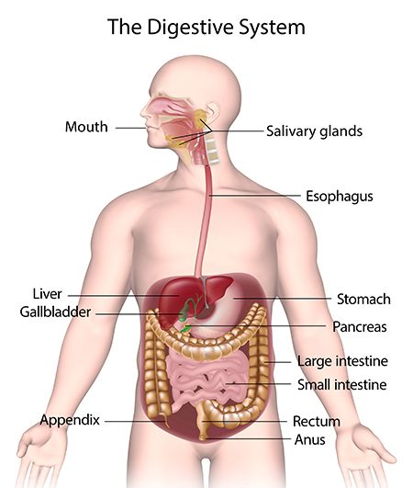

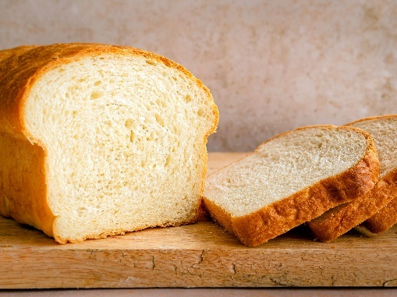

The gastrointestinal (GI) tract (the tract or passageway of the digestive system) is where we get all of our energy and nutrition. It's an incredible machine that's built to digest and absorb nutrients while also protecting the rest of the body from germs, viruses, and other foreign matter. From the mouth to the anus, the gastrointestinal system includes organs that help in digestion, absorption, and elimination (Food and Our Digestive Tract,2022). In this report, I will be explaining how white bread is digested in the body.

**Mouth and esophagus**

Digestion of carbohydrates starts with the mouth when you chew. Your teeth breaks the white bread into smaller pieces, and the salivary glands under your tongue and on the sides and roof of your mouth activate, stimulating the production of saliva, which helps moistens the bread making it easier to swallow and truing it into a moist lump called the bolus. "Your saliva also contains an enzyme called salivary amylase," this enzyme starts to break apart the starch in your bread into smaller, more simple carbohydrates, starch is just one of three types of carbohydrates, (Brittany Modell, RD, of Brittany Modell Nutrition and Wellness in New York City). When you swallow, the bread moves from the mouth to the throat where peristalsis (waves of muscular contractions) pushes the bolus down your esophagus into your stomach. It might take up to 3- 4 minutes ("How Starch Makes Its Way Through Your Body | Livestrong", 2022).

**Stomach**

In the stomach the bread goes through both mechanical and chemical digestion. The muscular walls of the stomach bound the bolus , breaking it into chunks. Hormones generated by cells in the stomach lining cause the stomach wall to release acids and enzyme-rich fluids, which dissolve the bread and break down its protein. These hormones also signal the pancreas, liver, and gall bladder to secrete digestive juices and transport bile, a yellowish-green liquid that aids in fat digestion. The bolus is now a frothy liquid termed chyme, which is ready to proceed to the small intestine after around 3-5 hours inside the stomach (“How your digestive system works” - Emma Bryce, 2022).

**Small intestine**

When the chyme reaches the small intestine, the pancreas produces digestive juice, which contains enzymes that help break down carbohydrates. This enzyme enters the small intestine through the pancreatic duct and gets to work on deconstructing carbohydrate into smaller chains and individual molecules. The small intestine makes digestive juice, which mixes with bile and pancreatic juice to complete the breakdown of carbohydrates. This bile is released from the gallbladder where it is kept for storage or sent to the small intestine for use. These digestive juices help carbohydrates into glucose, this happens in the middle and lower section of your small intestine where is it covered in millions of tiny projections called villi. These create a huge surface area to maximize molecule absorption and transference into the blood stream. Water and other nutrients are absorbed in the final part of the small intestine, and any water, minerals and fiber that isn't absorbed makes its way to the large intestine (How Starch Makes Its Way Through Your Body | Livestrong. (2022). This usually takes 2-6 hours.

**Large intestine**

In the large intestine, the body drains out most of the remaining fluid through the intestinal wall. What’s left is a soft mass called stool. The large intestine squeezes this into a pouch called the rectum. It takes about 36 hours for the food to go through the large intestine.

**Elimination**

In the elimination phase, the nerves of the rectum sense it expanding and tell the body when its time to expel the waste. The byproducts exit through the anus.

**Reference**

* Function, D. (2022). Digestive System: Diagram & Function – Studious Guy. Retrieved 15 May 2022, from <https://studiousguy.com/digestive-system-diagram-function/>
* Rich In Texture, This Buttermilk Bread Recipe Will Make Your Mouth Water. (2022). Retrieved 15 May 2022, from <https://www.thespruceeats.com/two-loaf-buttermilk-bread-recipe-428146>
* (Food and Our Digestive Tract, 2022). Retrieved 15 May 2022, from <https://www.innerbody.com/nutrition/food-and-our-digestive-tract>
* How Starch Makes Its Way Through Your Body | Livestrong. (2022). Retrieved 16 May 2022, from <https://axis-healthcare.website.homeip.net/article/488214-starch-and-digestion/>
* How your digestive system works - Emma Bryce (2022). Retrieved 16 May 2022, from <https://www.youtube.com/watch?v=Og5xAdC8EUI>

Sosan Amiri